**EXERCISE NO:**10

**REGISTER NO:**1518102072

**DATE** 21.11.20

**AIM:**

To write a python program print the number of upper case letters and lower case letters in a given string.

**PROGRAM:**

def string_test(s):

d={"UPPER_CASE":0, "LOWER_CASE":0}

for c in s:

if c.isupper():

d["UPPER_CASE"]+=1

elif c.islower():

d["LOWER_CASE"]+=1

else:

pass

print ("Original String : ", s)

print ("No. of Upper case characters : ",d["UPPER_CASE"])

print ("No. of Lower case characters : ",d["LOWER_CASE"])

s=input()

string_test(s)

**LINK:**

[**http://103.53.53.18/mod/vpl/forms/submissionview.php?id=325&userid=1686**](http://103.53.53.18/mod/vpl/forms/submissionview.php?id=325&userid=1686)

**OUTPUT:**

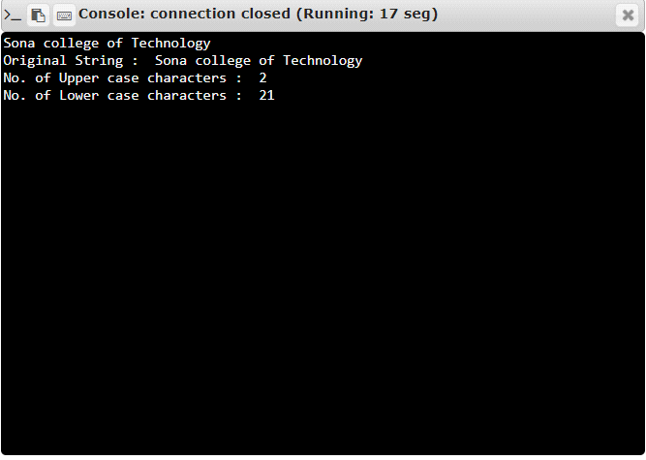

**RESULT:**

Thus the program is executed successfully and the output is verified.